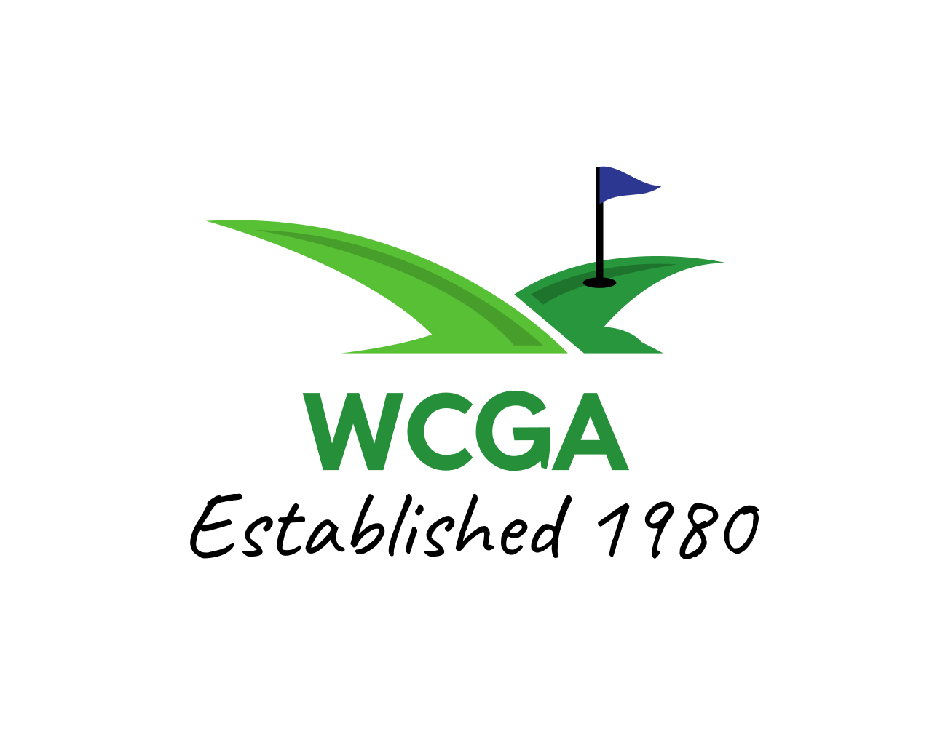
2023 WCGA AMATUER BETTER BALL
Ligonier Country Club: Saturday, June 17th
Please print clearly… ENTRY FORM (complete all information)

Prizes also awarded to low junior team (both players 18 and under) and low senior team (both players 60 and over) with better ball scores that do not qualify for larger regular prize. Number of prizes in each bracket based on the number of teams participating.

Name ______________________ Phone # ________________________

Address ______________________ Email _________________________

City ______________________ Zip _______________

Date of Birth: ______________________ Age: __________

Eligibility: To participate circle below how you meet our new eligibility criteria
1) I am County resident 2) Former resident 3) Member or play golf @____________

Name ______________________ Phone # ________________________

Address ______________________ Email _________________________

City ______________________ Zip _______________

Date of Birth: ______________________ Age: __________

Eligibility: to participate circle below how you meet our new eligibility criteria
1) I am County resident 2) Former resident 3) Member or play golf @____________

Tee Times: Begin @ 12:30pm Note: Field Limited

ENTRY FEE: (Cart included): $150/team Entries due by: June 13th

ENTRY FEE PAYABLE TO: Ligonier Country Club

Send entry form and fee to: Sean Knaus
c/o Ligonier Country Club
P.O. Box 597, Rt 711 South Country Club Rd.
Ligonier, PA 15658
Phone: (724) 238-7620

