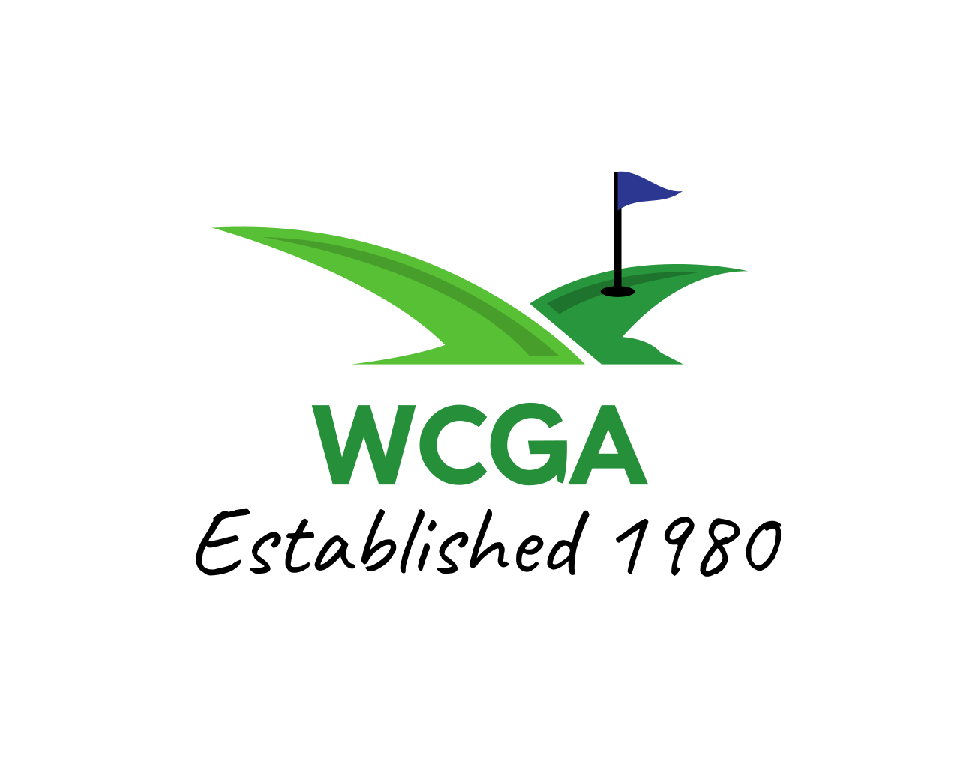
2023 Francis Driscoll – Parent/Child Golf Tournament

Mt. Odin Park Saturday, July 8th

*Please print clearly… ENTRY FORM (complete all information)

Format: 2 Person Scramble…Includes picnic dinner after play!
Prizes: Scratch Division…. and Adjusted Callaway Division

Parent/Older Adult
Name____________________ Email ______________________Phone #_________________

Address _________________ DOB ______________ Relationship to partner_____________

Eligibility: To participate circle below how you meet our new eligibility criteria
1) I am County resident 2) Former resident 3) Member or play golf @___________________

Child/Younger Adult
Name ____________________ Email ______________________ Phone #________________

Address __________________ DOB ___________ Relationship to partner_____________

Eligibility: To participate circle below how you meet our eligibility criteria
1) I am County resident 2) Former resident 3) Member or play golf @___________________

Team Eligibility Combos
- Parent/Child …biological, step, or adopted
- Grandparent/Child…biological, step, or adopted
- Uncle or Aunt can play with niece or nephew
- Only 1 Team member needs to meet county residence rule
SEE WEBSITE FOR COMPLETE ELIGIBILITY RULES
If anyone has eligibility questions, please contact Ryan Sikora (724) 989-0450

TEE TIME: 1:00 Shotgun LIMITED FIELD: First 40 Teams

ENTRY FEE: $100/Team $150/Team with 2 children ($50 per person)

SEND ENTRY AND FEE TO: Ryan Sikora
1073 Saybrook Drive
Greensburg, PA 15601
(724) 989-0450

CHECKS PAYABLE TO: WCGA

